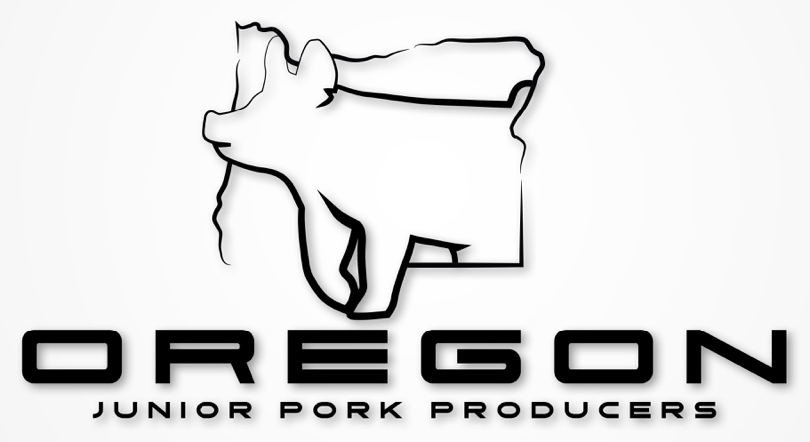

**2025-2026 Junior Board Application & State Representatives**

The purpose of the Oregon Junior Board of Directors and State Representativesis to provide an opportunity to build further relationships in the pork industry and expand upon their knowledge of the industry. The Junior Board of Directors will work alongside and assist the Oregon Pork Producers Board of Directors with increasing youth involvement. Throughout the young person’s time serving within a leadership role they will further develop their verbal and written communication skills. The successful young people will develop long lasting relationships while presented with real world experiences within the swine industry.

**Please view the attached document that outlines the responsibilities and expectations for board members and state representatives.**

**We will be selecting five young people to serve on this year’s board. If you wish to run for the Junior Board please select which position(s) you will be running for**

____ President

____ Vice President

____ Secretary

____ Treasurer

____ Reporter

____ Not Specified

**We will be selecting one State Representative from California, Idaho Oregon, and Washington. If you wish to run for one of these positions please select which state you are from**

____ California

____ Idaho

____ Oregon

____ Washington

**If you have any questions please contact:**

Email: oregonjuniorporkproducers@gmail.com

Youth Coordinator:

Nicki Hurley 541-740-1686

Danielle Bennett 503-318-7468

**2025-2026 Junior Board Junior Board & *State* *Representative* Application**

**Post Marked by: February 15th, 2025**

No late or incomplete applications will be considered

**Name:**

**Age:**

**DOB:**

**Address:**

**School:**

**Grade:**

**Email:**

**Phone Number:**

**Shirt Size:**

Applications Must Include

* A letter explaining
  + Your experience in the hog industry
  + What you plan to bring to this team
  + Plans and goals you have while serving on the team
  + Position desired and why
* A photo of yourself
  + Black and white or color
* Must be YQCA certified and provide a photo of your certification
  + Unless you plan to obtain it at the annual meeting

**Junior Signature:**

**Date:**

By signing this application I hereby agree that I have read and understand the requirements and expectations of the position I am applying for.

**Parent/Guardian Signature:**

**Date:**

By signing this application I hereby agree that I have read and understand all the requirements and expectations of the position my junior is applying for.

Please note that no late or incomplete applications will be accepted

**Send completed applications to:**

Oregon Junior Pork Producers

32640 Peoria Road SW

Albany, OR 97321

**Or Email all** **completed applications to:**

[oregonjuniorporkproducers@gmail.com](mailto:oregonjuniorporkproducers@gmail.com)

The email must be time stamped no later than February 10th, 2025at 11:59pm