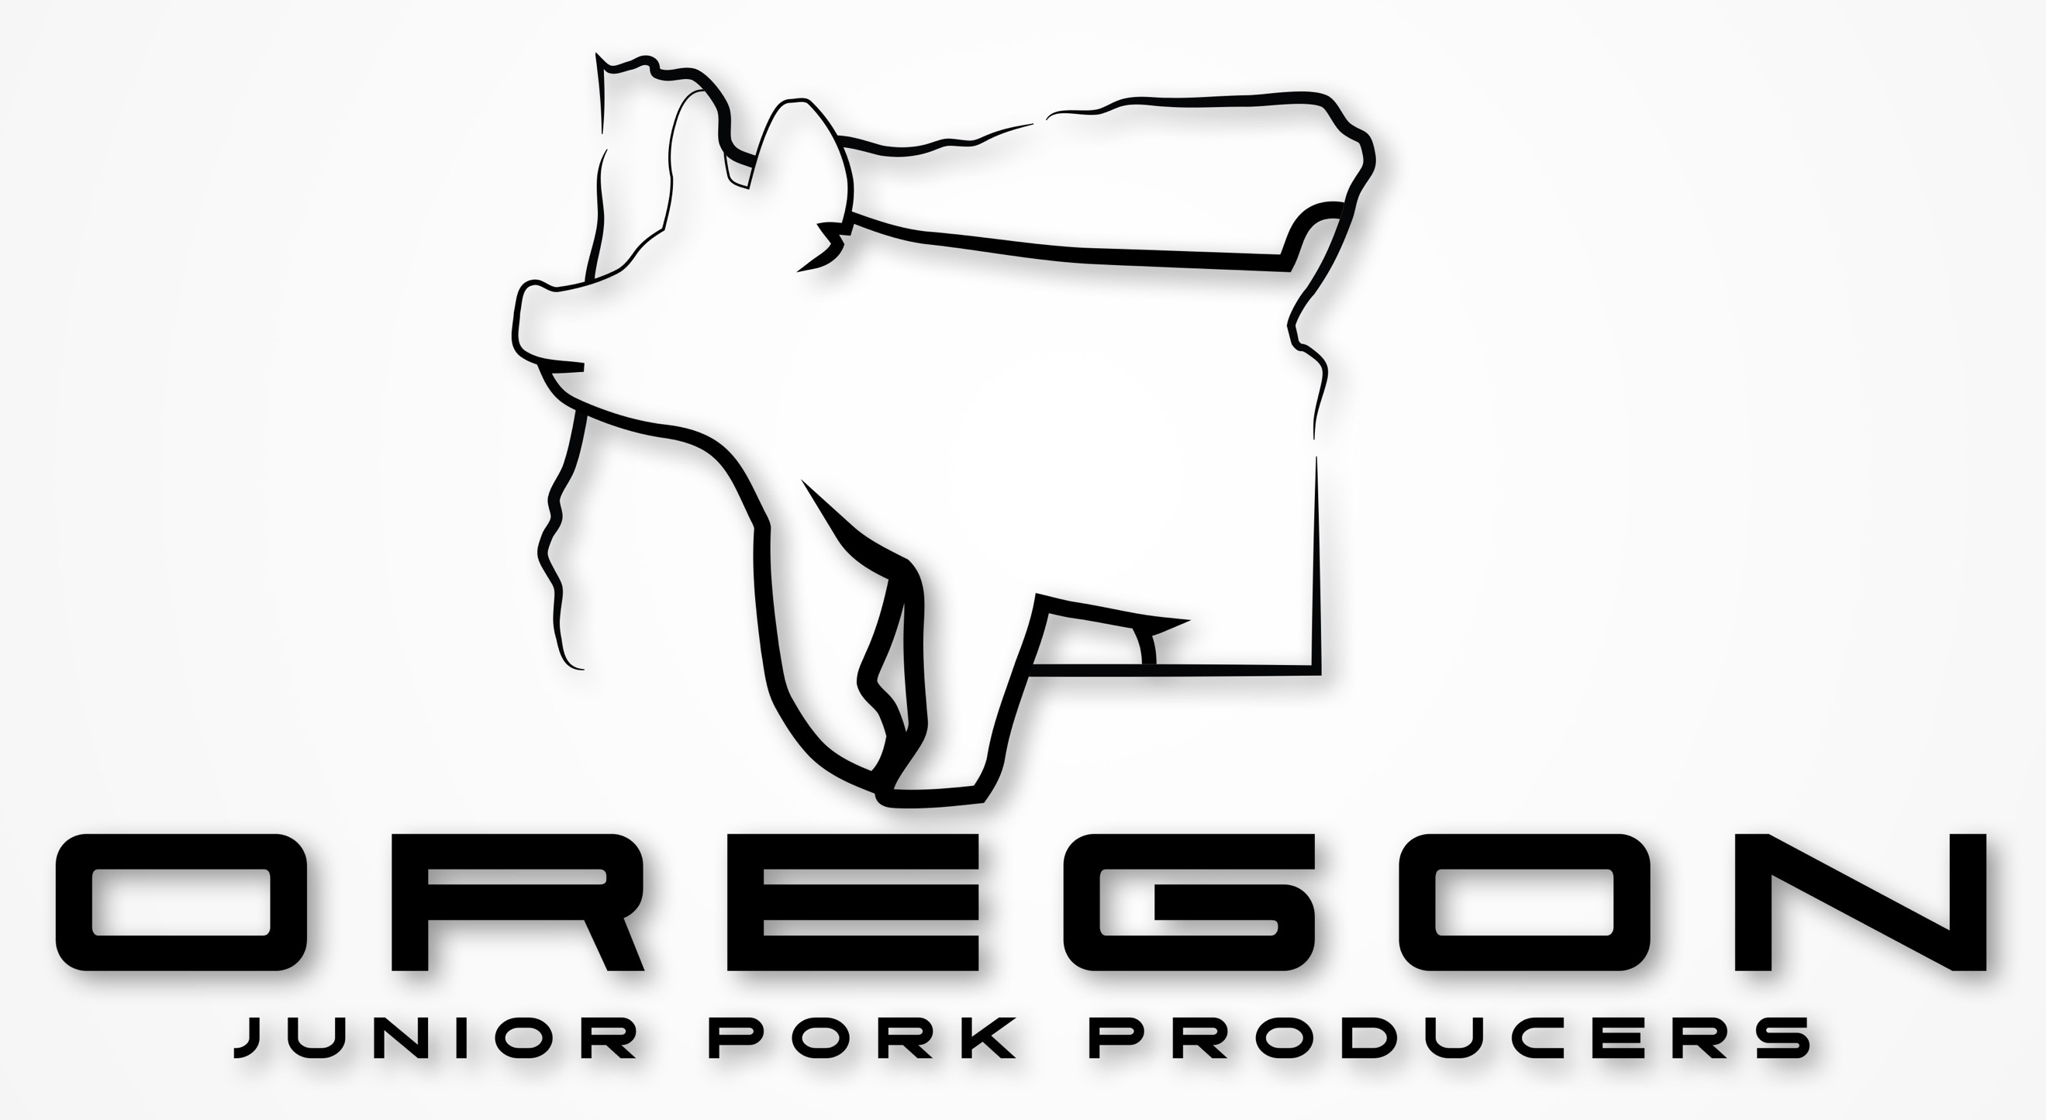

**Junior Board & State Representatives Requirements**

**Team requirements will include but not be limited to:**

* Must be no younger than 12 and no older than 19 when applying for a position
* Must be or become a current Oregon Junior Pork Producers Member
  + You must be a paid member the whole time you are in office
* You must live in the State of Oregon to be eligible for the President, Vice President, Secretary, Treasurer, or Reporter positions.
* Must be YQCA certified or obtain the certification at the annual meeting
  + You must maintain certification while in office
* Participate and help run events throughout the year with the OPP Youth Coordinators such as but not limited to:
  + Youth Fundraising
  + Youth Sweepstakes
  + Travel to shows such as Southern Oregon Jr. Classic, Jr. Pacific International Livestock Expo, and Oregon State Fair
  + Attend one weekend planning trip in a central location after being installed; Date TBD

**Board Position Explanations and Requirements:**

**President** responsibilities include but not limited to:

*Must be at least 15 to apply for this position

* Will be in charge of running and scheduling all meetings and conference calls
* Will be in charge of making sure that all duties and tasks are being met
  + Work closely with Youth Coordinators to ensure that all tasks and duties are being fulfilled
* Work with Vice President to present ideas to the Oregon Pork Producers Board for approval

**Vice President** responsibilities include but not limited to:

*Must be at least 15 to apply for this position

* Will assist the President when needed and reside over meetings when the President is absent
* Will be in charge of making sure that all duties and tasks are being met
* Will work with President to present ideas to the Oregon Pork Producers Board for approval

**Secretary** responsibilities include but not limited to:

* Write minutes for each meeting held by the OJPP Board
  + Share these with all team members and youth coordinators
* Work with the Reporter to create the monthly newsletter, What’s Shakin Bacon
* Maintain and update the emailing list for newsletter and updates
* If the Reporter is not able to attend a jackpot show the secretary will be in charge of taking photos at that show and posting pictures of champions on social media stories

**Treasurer** responsibilities include but not limited to:

*Must be at least 15 to apply for this position

* Work with the Oregon Pork Producers Treasurer Officer to
  + Get bank account statements
  + Get fund withdraws approved by OPP Board
  + Will work with OPP Treasurer to deposit funds and perform reimbursements
* Will be in charge of all funds collected at shows and or during fundraising events until turned over to OPP Treasurer
* Will present a Treasurer report at every meeting

**Reporter** responsibilities include but not limited to:

* Create and maintain a social media content calendar
  + Maintain all OJPP social media channels (with the exception of Facebook)
* Work with the secretary to create the monthly newsletter, What’s Shakin Bacon
* Will work with team to implement any and all approved promotions such as events like an Oregon FFA State Convention Booth. Or promotions at shows such as OJPP Hog Boards, tri fold information, and more
* Will be in charge of taking photos of junior members showing at jackpot shows and of all champions to post on social media stories
  + - If you will not be able to attend certain jackpot shows you must inform the secretary and youth coordinators so that the secretary can take over this duty for that show

**State Representative Explanation and Requirements:**

One representative will be selected from each state consisting of Oregon, Washington, Idaho, and California

**Requirements will include but not be limited to:**

* Must be no younger than 12 years old and no older than 19 when applying for a position
* Must be or become a current Oregon Junior Pork Producers Member
  + You must be a paid member the whole time you are in office
* Must be YQCA certified or obtain the certification at the annual meeting
  + You must maintain certification while in office
* Travel to shows such as Southern Oregon Jr. Classic, Jr. Pacific International Livestock Expo, and Oregon State Fair
* Work with OJPP Board and bring forward ideas presented from members of their state
* Promote being a OJPP member to state as well as relay ideas and upcoming events to their state. State representatives will be non-voting members of the OJPP Board but will be allowed to be part of the discussions